For the millions and millions of people using the Vault integration for SharePoint 2010, here is a utility that you might find useful. It’s a calendar web part that shows you when your Vault ECOs are due.
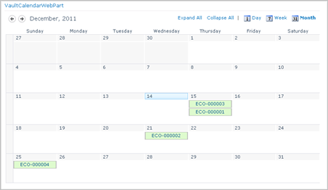
(click for full image)
The data can be driven from any Vault Change Order list in SharePoint. Clicking on the calendar entry brings up the detail view for that ECO.
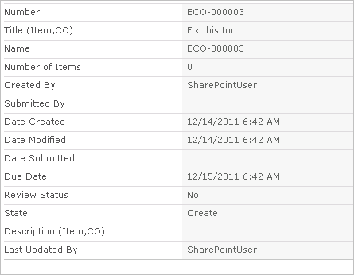

Requirements:
- Vault Professional 2012
- SharePoint 2010 Standard or Enterprise
- The Vault integration for SharePoint 2010
NOTE: The SharePoint administrator needs to deploy and enable the web part before it can be used. See readme file for instructions.
Click here to download the application
Click here to download the source code

Note from the programmer:
I’ll admit, I have next to no experience building web parts. The end result seems to work fine, but the code probably doesn’t comply with the standards and practices.
Also, if you know an easier way to deploy a web part, please let me know.

As with all the samples on this site, the legal disclaimer applies.

